Experiment No-03
Study of CMOS AND Gate Schematics in Cadence Virtuoso Software
1.1 Objectives
The main objectives of this experiment are summarized as:
- To understand the concept and operation of a two-input CMOS AND gate as a fundamental building block of digital logic circuits.
- To become familiar with the Cadence Virtuoso schematic editor and the standard IC design flow used to create standard cells.
- To design the transistor-level schematic of a two-input CMOS AND gate, implemented as a NAND stage (two parallel PMOS transistors as the pull-up network and two series NMOS transistors as the pull-down network) followed by a CMOS inverter stage, using devices from the gpdk090 technology library, and to generate its schematic symbol.
- To construct a test bench for the AND gate, with two independent pulse sources at its two inputs, and verify its functionality through transient simulation using Spectre in the Analog Design Environment (ADE L).
- To obtain and analyze the transient input/output wave-forms of the designed AND gate for all combinations of its two input signals, and to verify them against the AND truth table.
Keywords- CMOS AND gate, NMOS, PMOS, Cadence Virtuoso, schematic editor, Spectre, NAND-inverter cascade, transient response, truth table, standard cell.
1.2 Theory
An AND gate is a fundamental digital logic gate whose output is the logical AND of its inputs. For a two-input AND gate with inputs A and B and output Y, the operation is expressed by the Boolean expression Y = A·B. The output is HIGH (logic 1) only when both inputs are HIGH (logic 1); for every other combination of inputs, the output is LOW (logic 0). The truth table of an ideal two-input AND gate is shown in Table-1.1.
A | B | Y = A·B
0 | 0 | 0
0 | 1 | 0
1 | 0 | 0
1 | 1 | 1
Table-1.1. Truth table of an ideal two-input AND gate.
1.2.1 The CMOS AND Gate (NAND–Inverter Cascade)
Unlike the inverter and the NAND gate, a single stage of complementary CMOS transistors cannot directly realize a non-inverting AND function, because a purely complementary pull-up/pull-down network always produces an inverted (NAND-type) output. A two-input CMOS AND gate is therefore built as a cascade of two stages: a first stage that is a standard two-input NAND gate, consisting of two PMOS transistors (PM0, PM1) connected in parallel between VDD and an internal node, and two NMOS transistors (NM0, NM1) connected in series between that internal node and VSS; and a second stage that is a CMOS inverter, consisting of one PMOS transistor (PM2) and one NMOS transistor (NM2), which inverts the internal NAND node to produce the final output Vout.
The internal node between the two stages is pulled LOW only when both series NMOS transistors of the first stage are simultaneously ON, which happens only when both A and B are HIGH; for every other input combination, the internal node is pulled HIGH by the parallel PMOS pull-up network. The inverter stage then inverts this internal node, so the final output Vout is HIGH only when both A and B are HIGH, and LOW for every other input combination the correct AND function. Because neither the NAND stage nor the inverter stage ever has its pull-up and pull-down networks both fully ON for the same static input combination, the static power dissipation of the overall CMOS AND gate is ideally zero, just as for the individual NAND and inverter stages.
1.2.2 Transistor Sizing and the Two-Stage Cascade
As in the standalone NAND gate, the pull-down network of the first (NAND) stage consists of two series NMOS transistors (a transistor “stack”), which gives the internal node a higher effective pull-down resistance than a single NMOS transistor of the same width would provide, tending to slow its HIGH-to-LOW transition. The second (inverter) stage, however, uses only a single PMOS and a single NMOS transistor, so it switches with the same speed characteristics as a standalone CMOS inverter and restores a full-swing, sharply-transitioning output at Vout.
Because the mobility of holes in a PMOS transistor is lower than the mobility of electrons in an NMOS transistor, a PMOS device must be made wider than an NMOS device of the same length to provide comparable drive strength. In this experiment, the same transistor dimensions used for the earlier CMOS inverter and NAND gate designs were retained for all three PMOS and all three NMOS devices of the AND gate: every PMOS device (PM0, PM1, PM2) was sized with a total width of 720 nm, and every NMOS device (NM0, NM1, NM2) with a total width of 240 nm, for the same channel length of 100 nm, giving the same 3:1 PMOS-to-NMOS width ratio as before. Keeping these dimensions unchanged preserves consistency with the earlier experiments for both the NAND stage and the inverter stage.
1.2.3 Cadence Virtuoso Design Flow
In this experiment, the CMOS AND gate is designed and verified using the Cadence Virtuoso IC design environment. The overall flow consists of creating a design library attached to a process technology library (gpdk090), drawing the transistor-level schematic in the Schematic XL editor by placing and sizing three PMOS and three NMOS instances and wiring them into a NAND stage followed by an inverter stage, generating a schematic symbol for the AND cell, and finally building a separate test bench schematic in which the AND symbol is instantiated along with two independent input sources and supply sources. The test bench is then simulated using the Spectre simulator inside the Analog Design Environment (ADE L) to verify the AND gate’s transient behaviour.

1.3 Hardware/Software Used for the Experiment
1. Cadence Virtuoso Schematic Editor (Schematic XL)
2. Virtuoso Analog Design Environment (ADE L)
3. Spectre circuit simulator
4. gpdk090 generic process design kit (technology library)
5. Three NMOS and three PMOS transistors (gpdk090_nmos1v, gpdk090_pmos1v)
6. Two pulse voltage sources (vpulse), a DC voltage source (vdc) and ground (gnd) from analogLib
7. Linux workstation running the Cadence design environment
1.4 Experimental and Simulation Analysis
A design library (AND_Gate) was created and attached to the gpdk090 technology library, and a schematic cellview (carried over from the earlier inverter/NAND template and therefore still internally named inverter) was modified within it to implement the two-input AND function. Three NMOS and three PMOS instances were placed in the schematic, sized as described in Section 1.2.2, and wired into a first NAND stage (PM0, PM1, NM0, NM1) followed by a second inverter stage (PM2, NM2), with two input pins (A and B), an output pin, and the VDD/VSS supply pins. A schematic symbol was then generated for the AND cell. A separate test schematic (inverter_test) was built in which the AND symbol was instantiated with two independent pulse sources at its two inputs and a DC supply and ground connected to its power pins, and the design was simulated in ADE L using the Spectre simulator. Each of these steps is illustrated below.
1.4.1 Transistor Sizing and Parameter Selection
The width and length of each transistor were set in the Add Instance window at the time of placement. As in the earlier inverter and NAND designs, each NMOS transistor (NM0, NM1, NM2) was sized with a total width of 240 nm and a channel length of 100 nm, while each PMOS transistor (PM0, PM1, PM2) was sized with a total width of 720 nm and the same channel length of 100 nm, giving the 3:1 PMOS-to-NMOS width ratio discussed in Section 1.2.2. The parameter selection window used for setting the NMOS device dimensions is shown in Figure-1.1.
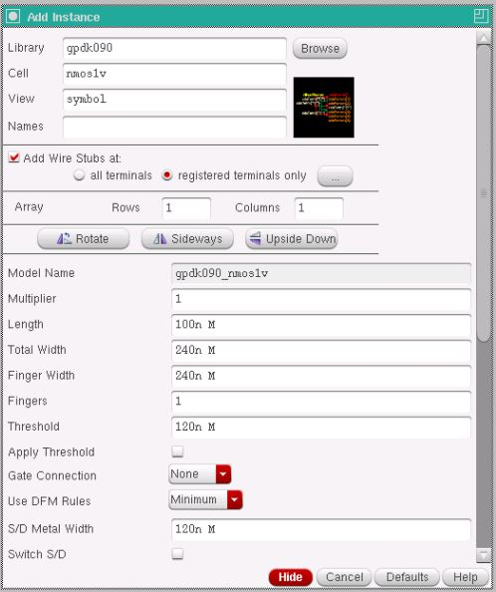
Figure-1.1. Add Instance window showing the width and length parameters set for the NMOS transistor (Total Width = 240n, Length = 100n).
Device | Width (W) | Length (L)
NMOS – NM0, NM1, NM2 (gpdk090_nmos1v) | 240 nm | 100 nm
PMOS – PM0, PM1, PM2 (gpdk090_pmos1v) | 720 nm | 100 nm
Table-1.2. Device parameters used for the NMOS and PMOS transistors in the AND gate schematic.

1.4.2 Transistor-Level Schematic of the CMOS AND Gate
The two PMOS transistors of the first stage (PM0, PM1) were connected to the VDD pin and connected in parallel between VDD and an internal node, while the two NMOS transistors (NM0, NM1) were connected in series between that internal node and the VSS pin. The gates of one PMOS and one series NMOS were tied together to form input A (Vin1), and the gates of the other PMOS and NMOS were tied together to form input B (Vin2). The internal node was then connected to the gates of the second-stage inverter transistors (PM2, NM2), whose drains were tied together to form the output net (Vout), with PM2 connected to VDD and NM2 connected to VSS. The complete transistor-level schematic of the CMOS AND gate, with all pins and wires labeled, is shown in Figure-1.2.

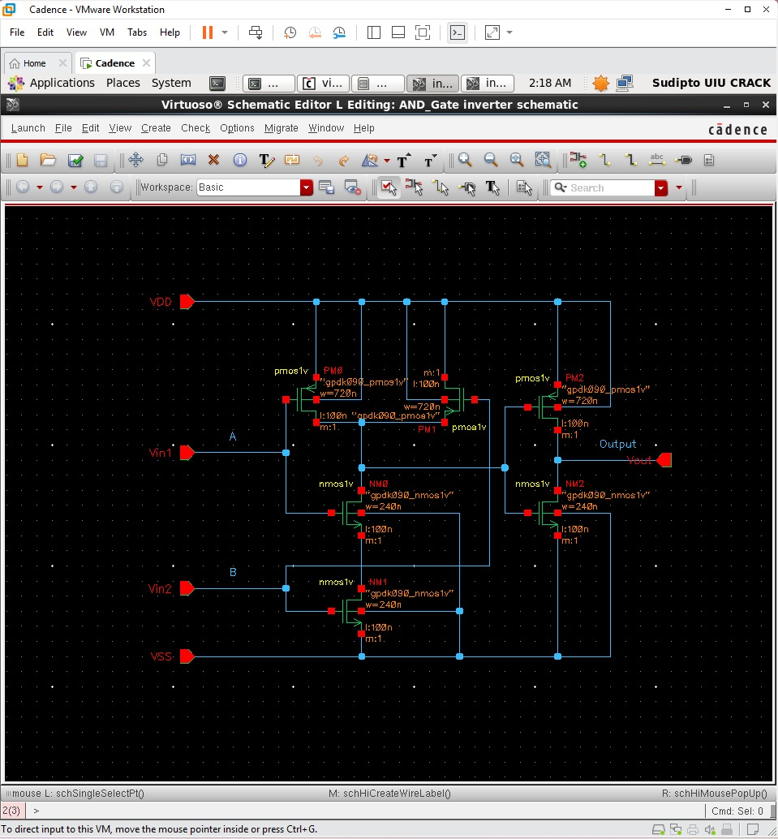
Figure-1.2. Complete transistor-level schematic of the CMOS AND gate, showing the first-stage NAND network (PM0, PM1 in parallel; NM0, NM1 in series) producing an internal node, and the second-stage inverter (PM2, NM2) that inverts this node to produce the final output Vout, with the A, B, Vout, VDD and VSS pins labeled.
1.4.3 Schematic Symbol Generation
After the schematic was checked and saved without errors, a schematic symbol was generated from the cell-view using Create → Cellview → From Cellview, with Vin1 (A) and Vin2 (B) placed as the two left-side input pins, Vout placed as the right-side output pin, and VDD and VSS placed as the top and bottom pins. The default shape generated by Virtuoso was replaced with the conventional two-input AND symbol, a curved AND-gate body without an output bubble (distinguishing it from the NAND symbol used previously), as shown in Figure-1.3.

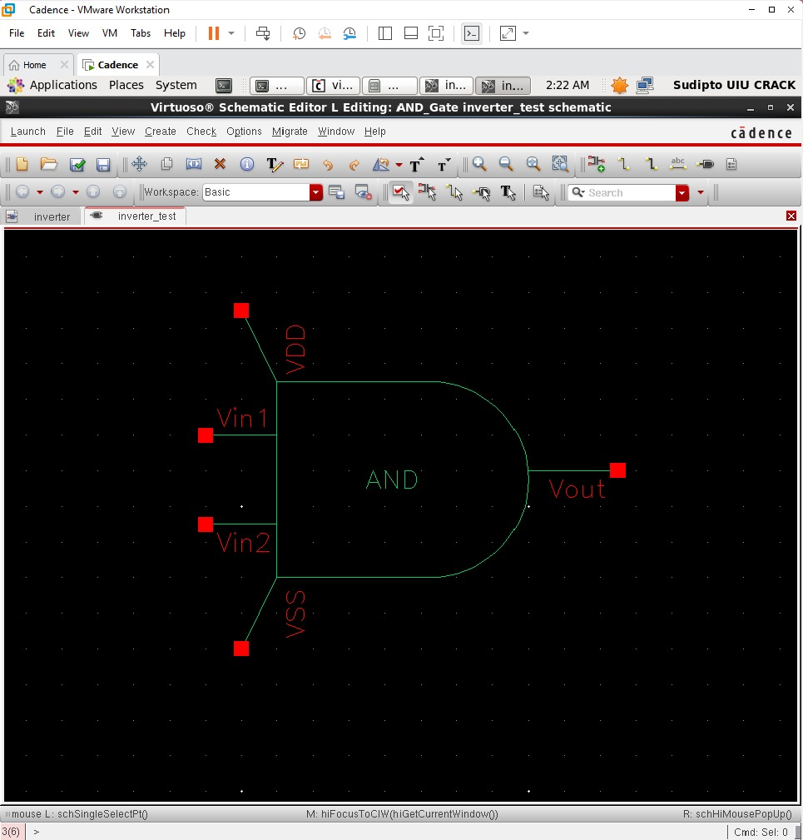
Figure-1.3. Generated schematic symbol of the CMOS AND gate, showing the two inputs Vin1 and Vin2, the output Vout, and the VDD and VSS supply pins.
1.4.4 Test Bench Construction and Source Addition
A separate schematic, inverter_test, was created to verify the AND gate. The generated AND symbol was instantiated, and two independent pulse voltage sources (vpulse) from analogLib were connected to its two inputs: source V1 was connected to input A (Vin1) with voltage1 = 0 V, voltage2 = 1.8 V, period = 20 ns and pulse width = 10 ns, while source V2 was connected to input B (Vin2) with voltage1 = 0 V, voltage2 = 1.8 V, period = 40 ns and pulse width = 20 ns, so that all four input combinations of A and B are exercised over the course of the simulation. A DC voltage source (vdc) set to 1.8 V and a ground (gnd) were connected to the VDD and VSS pins respectively, and the input and output nets were named Vin1, Vin2 and Vout using Create → Wire Name. The completed test bench, with all sources added, is shown in Figure-1.4.

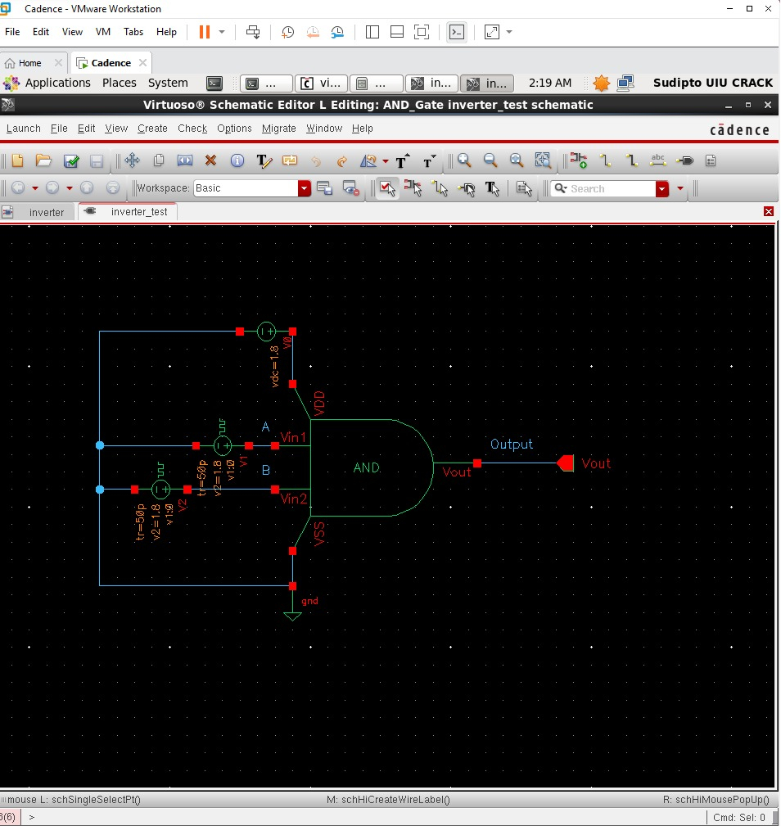
Figure-1.4. Test bench schematic (inverter_test) with the two pulse input sources V1 and V2, the DC supply, ground, and the AND symbol, with the Vin1, Vin2 and Vout nets labeled.
1.4.5 Input Source Parameter Selection
The Add Instance windows used to configure the two pulse sources and the DC supply are shown in Figure-1.5, Figure-1.6 and Figure-1.7. Figure-1.5 shows the parameters of source V1 driving input A, with Voltage 1 = 0 V, Voltage 2 = 1.8 V, a period of 20 ns, a pulse width of 10 ns, and rise/fall times of 50 ps. Figure-1.6 shows the parameters of source V2 driving input B, configured identically except for a longer period of 40 ns and a pulse width of 20 ns, so that B toggles at half the frequency of A. Figure-1.7 shows the Add Instance window for the vdc source used to set the VDD supply to a DC voltage of 1.8 V.

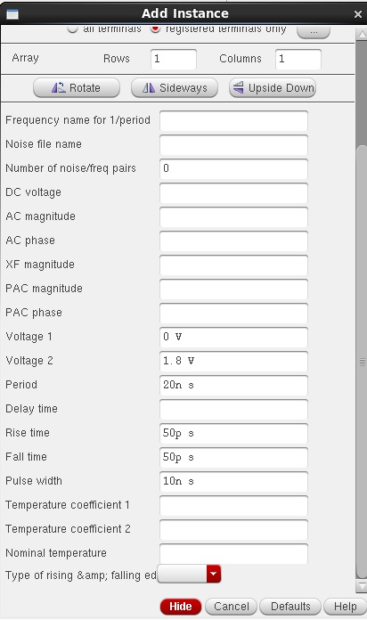 | 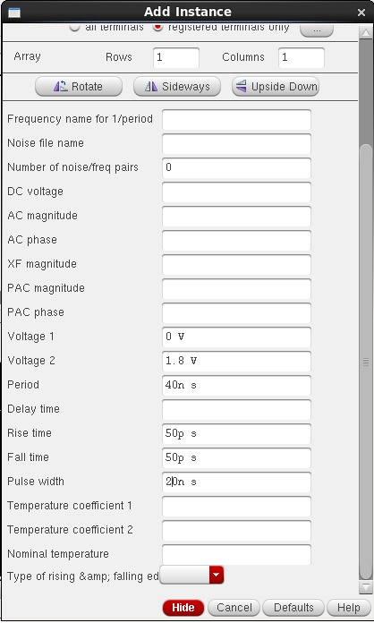
Figure-1.5. Add Instance window showing the pulse source V1 (AND gate input A): Voltage 1 = 0 V, Voltage 2 = 1.8 V, period = 20 ns, pulse width = 10 ns. | Figure-1.6. Add Instance window showing the pulse source V2 (AND gate input B): Voltage 1 = 0 V, Voltage 2 = 1.8 V, period = 40 ns, pulse width = 20 ns.
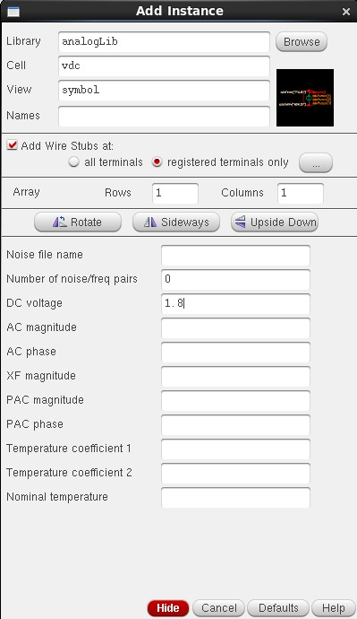
Figure-1.7. Add Instance window showing the vdc source used for the VDD supply, set to a DC voltage of 1.8 V.
1.4.6 Simulation Setup
The test bench was simulated in ADE L using the Spectre simulator, with the gpdk090 Spectre model library added under Setup → Model Libraries. A transient analysis was configured with a stop time of 200 ns so that several cycles of both the 20 ns-period input A and the 40 ns-period input B were captured. The input nets A and B and the output net Vout were selected as the outputs to be plotted, and the simulation was run using Simulation → Netlist and Run.
1.4.7 Simulation Results: Input and Output Waveforms
Figure-1.8 shows the simulated transient response of the AND gate. The left-hand plot shows the two pulse inputs, A (top) and B (bottom), each switching between 0 V and 1.8 V, with A having a 20 ns period and a 10 ns pulse width and B having a 40 ns period and a 20 ns pulse width, over an 80 ns window. The right-hand plot shows the corresponding output Vout over a shorter, zoomed-in 30 ns window. Consistent with the AND function, Vout is observed to go HIGH only during the interval where A and B are simultaneously HIGH near the start of the simulation, and to remain LOW for the rest of the observed window whenever A and B are not both HIGH at the same time, in direct agreement with the two-input AND truth table given in Table-1.1.
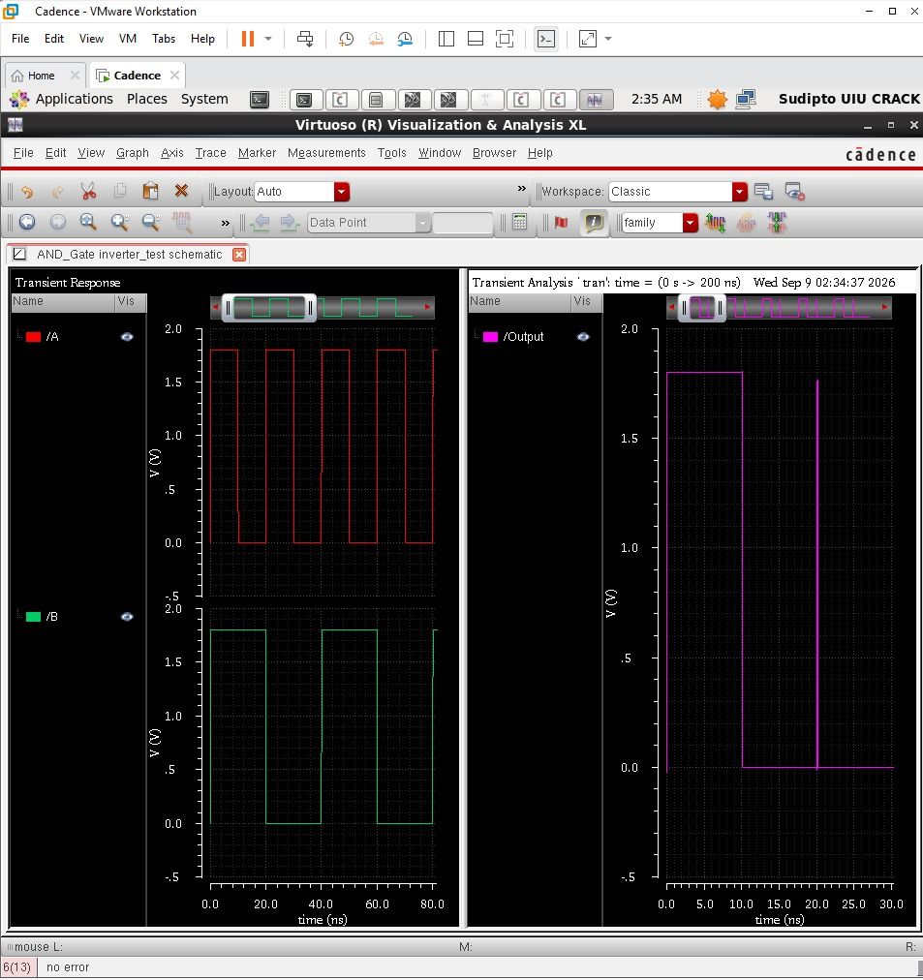
Figure-1.8. Simulation results: the two pulse inputs A and B (left) and the corresponding AND output Vout, shown on a zoomed time axis (right).
1.5 Discussion
The simulated behaviour of the designed circuit was found to be in agreement with the theoretical operation of a CMOS AND gate described in Section 1.2. The transient simulation confirmed that the output Vout was HIGH only during the interval where both input A and input B were simultaneously HIGH, and LOW otherwise, matching the expected truth table (Table-1.1). This confirms that cascading a two-input NAND stage with a CMOS inverter stage correctly restores the non-inverted AND function at the output. Because neither stage ever has its pull-up and pull-down networks both fully ON for the same static input combination, the circuit is also expected to dissipate negligible static power, consistent with the fundamental advantage of CMOS logic. Retaining the same transistor dimensions used for the earlier CMOS inverter and NAND gate designs (WP = 720 nm, WN = 240 nm, L = 100 nm for all six devices) kept the design consistent with those experiments, although the series NMOS stack in the first stage is expected to make its internal HIGH-to-LOW transition somewhat slower than a single-transistor stage; the added inverter stage did not, however, affect the correctness of the final logical output observed in simulation.
1.6 Conclusion
In this experiment, a two-input CMOS AND gate was successfully designed at the transistor level in Cadence Virtuoso, implemented as a two-input NAND stage (two parallel PMOS and two series NMOS transistors) cascaded with a CMOS inverter stage (one PMOS and one NMOS transistor), using devices from the gpdk090 technology library, and its schematic symbol was generated. A test bench was constructed with two independent pulse sources at the two inputs and a DC supply, and the circuit was verified through transient simulation using Spectre in ADE L. The observed input-output waveforms confirmed that the circuit correctly performs the logical AND operation, producing a HIGH output only when both inputs were simultaneously HIGH, consistent with the AND truth table. This experiment provided practical, hands-on experience with building a composite standard cell from two cascaded logic stages (NAND + inverter), which forms the basis for more complex digital and mixed-signal IC design in subsequent experiments.

